1:Install Apache and run Apache on port number 82
Created a server logged in to server
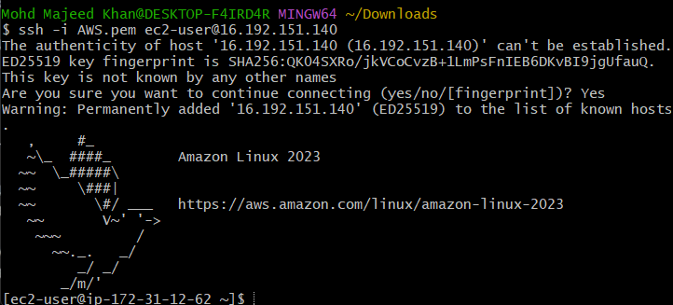
yum install httpd
systemctl start httpd
systemctl status httpd
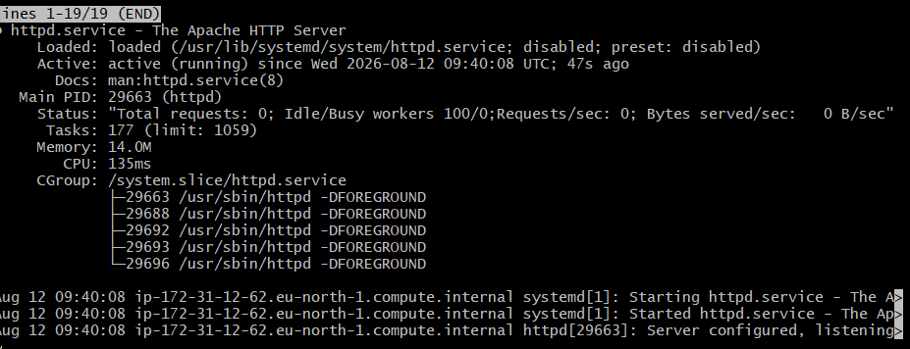
Netstat -na | grep 80
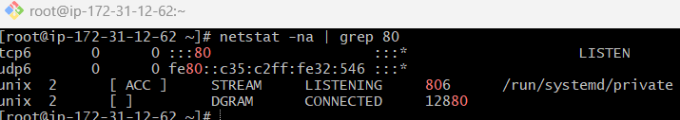
lsof -i tcp:80 - then ps -ef | grep httpd (two different command in single image)
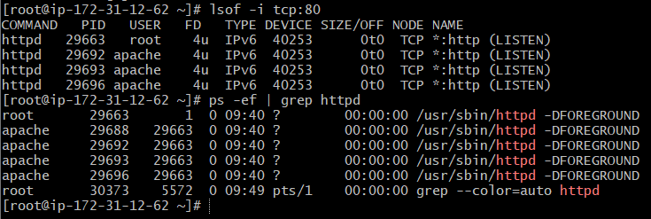
“It works!”, which confirms that Apache (httpd) is successfully serving the webpage from your EC2 instance.
You can consider the Apache setup completed

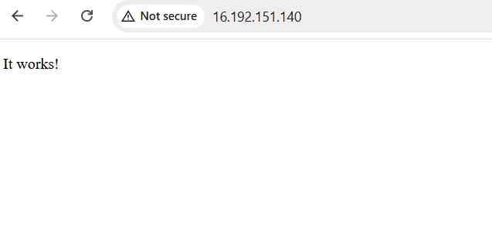
Listen to port :80
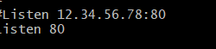
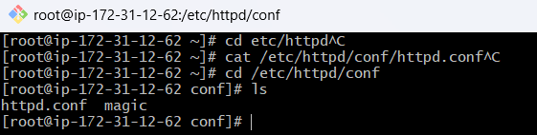
Listen to port 81
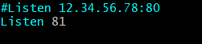

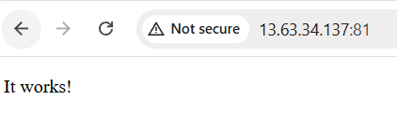
Process for creating/changing a static website page in Apache.
Default deployment location: /var/www/html
Apache configuration file: /etc/httpd/conf/httpd.conf
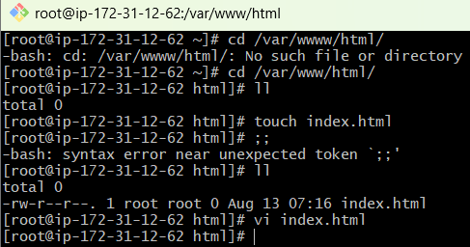

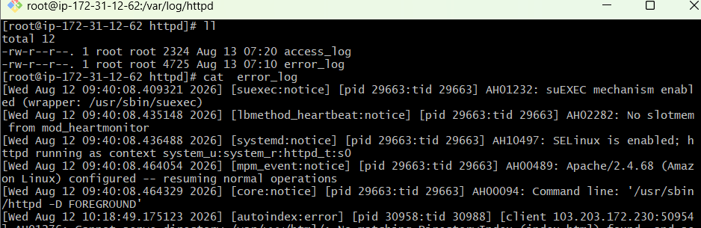
Log file = a file where the system or application records events/activity.For example, on your server:
/var/log/httpd/access_log
/var/log/httpd/error_log
Journalctl
2.Install nginx and run nginx on port number 81.
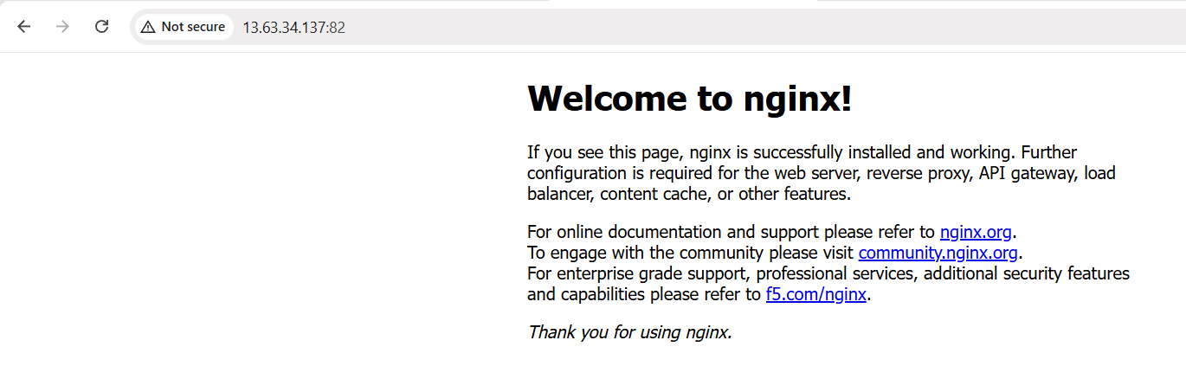
3: Deploy a sample index.html file on nginx.
1: sudo vi /usr/share/nginx/html/index.html
2: Inside vi :%d
3: <!DOCTYPE html> <html> <head> <title>My Nginx Website</title> </head> <body> <h1>Welcome to My Nginx Website</h1> <p>Nginx is successfully serving my index.html file.</p> </body> </html>
4: cat /usr/share/nginx/html/index.html
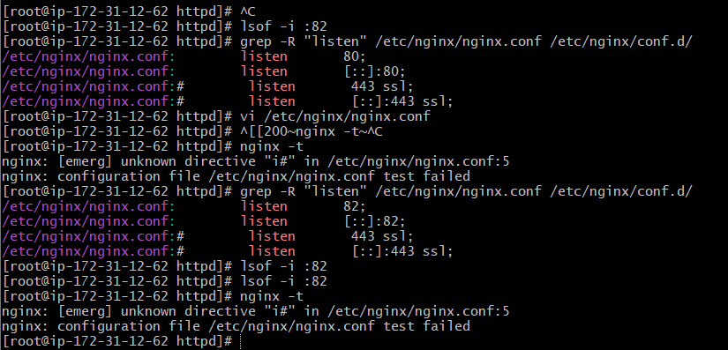
4: Deploy a sample index.html file on Apache
1: sudo vi /usr/share/nginx/html/index.html
2: Inside vi :%d
3:<!DOCTYPE html>
<html>
<head>
<title>My Apache Website</title>
</head>
<body>
<h1>Welcome to My Apache Website</h1>
<p>Apache is successfully serving my index.html file.</p>
</body>
</html>
4:cat /var/www/html/index.html command
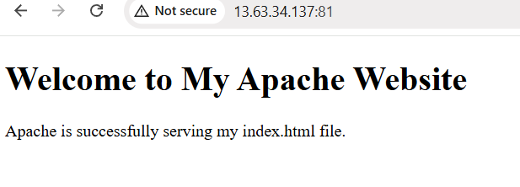
5: Install Apache tomcat on port number 8082
1: sudo dnf install java-17-amazon-corretto -y
2: java -version
3: openjdk version "17.0.20" 2026-07-21 LTS
Next step — Download Tomcat
1: cd /opt
2: sudo wget https://dlcdn.apache.org/tomcat/tomcat-10/v10.1.57/bin/apache-tomcat-10.1.57.tar.gz
3: ls -lh /opt/apache-tomcat-10.1.57.tar.gz
Tomcat downloaded successfully.
Step 3 — Extract Tomcat
Run : sudo tar -xzf /opt/apache-tomcat-10.1.57.tar.gz -C /opt
Then check: ls -l /opt/
apache-tomcat-10.1.57
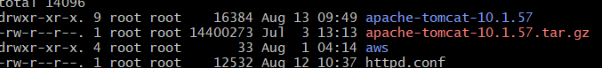
Step 4 — Open Tomcat configuration:
- 1:sudo vi /opt/apache-tomcat-10.1.57/conf/server.xml
- Inside vi, look for: <Connector port="8080"
- Change 8080 → 8082:
- Save ::wq!
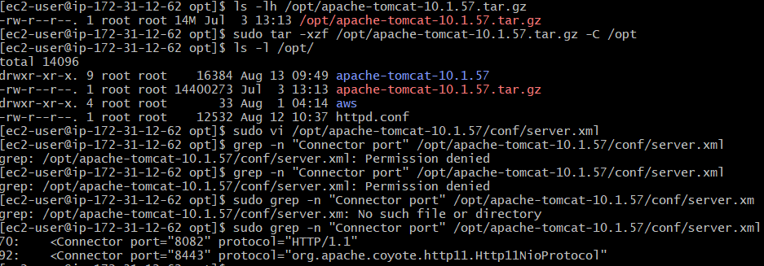
Tomcat is configured correctly for port 8082.
Next step — Start Tomcat
Run: sudo /opt/apache-tomcat-10.1.57/bin/startup.sh
You should see something similar to:
Tomcat started.
Then check port 8082 :
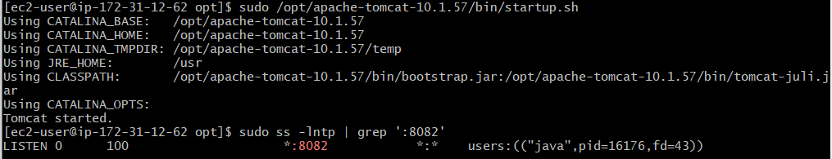
✅ Java 17 installed
✅ Tomcat 10.1.57 downloaded
✅ Tomcat extracted
✅ Tomcat configured from 8080 → 8082
✅ Tomcat started
✅ Port 8082 is listening
Next step — AWS Security Group
Go to your EC2 Security Group → Inbound rules and add:
Type: Custom TCP
Port: 8082
Source: IPv4 >0.0.0.0/0 save rule
Then test in your browser
Open:
http://13.63.34.137:8082
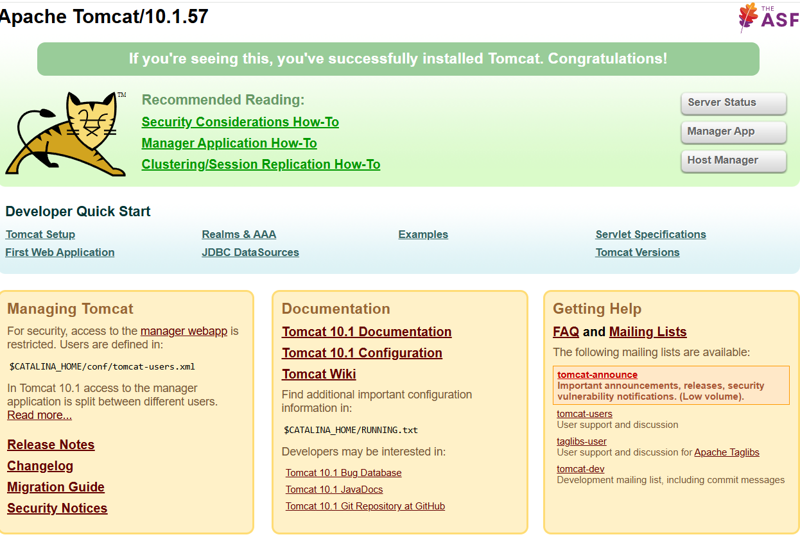
Apache Tomcat welcome page.
6:Deploy a sample app on webapps
1. Go to Tomcat webapps directory
cd /opt/apache-tomcat-10.1.57/webapps
If permission is denied, use the full path with sudo in the next commands.
2. Create sample application directory
sudo mkdir -p /opt/apache-tomcat-10.1.57/webapps/sampleapp
3. Create index.html
sudo vi /opt/apache-tomcat-10.1.57/webapps/sampleapp/index.html
Press i and add:
<!DOCTYPE html>
<html>
<head>
<title>Sample Tomcat App</title>
</head>
<body>
<h1>Welcome to My Sample Tomcat App</h1>
<p>Tomcat is successfully deploying my application.</p>
</body>
</html>
Save and exit:
Esc
:wq
Enter
4. Verify the application file
sudo cat /opt/apache-tomcat-10.1.57/webapps/sampleapp/index.html
5. Check Tomcat port
sudo ss -lntp | grep ':8082'
Expected:
LISTEN ... :8082 ... java
6. Access the application
Open in browser:
http://<EC2-PUBLIC-IP>:8082/sampleapp/
Example:
http://13.63.34.137:8082/sampleapp/
Expected Result
Welcome to My Sample Tomcat App

Tomcat is successfully deploying my application.

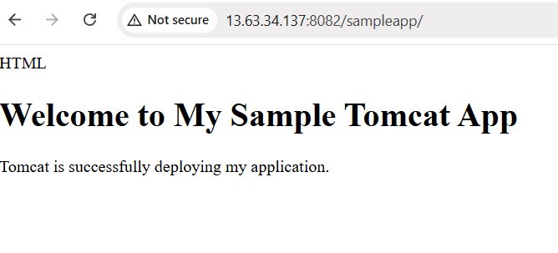
7: Create a tomcat.service file for tomcat.
Create a tomcat.service file for Tomcat
1. Create the service file
sudo vi /etc/systemd/system/tomcat.service
Press i and paste:
[Unit]
Description=Apache Tomcat Web Application Server
After=network.target

[Service]
Type=simple
User=root
Group=root

Environment="JAVA_HOME=/usr/lib/jvm/java-17-amazon-corretto"
Environment="CATALINA_HOME=/opt/apache-tomcat-10.1.57"
Environment="CATALINA_BASE=/opt/apache-tomcat-10.1.57"

ExecStart=/bin/bash /opt/apache-tomcat-10.1.57/bin/catalina.sh run
ExecStop=/bin/bash /opt/apache-tomcat-10.1.57/bin/shutdown.sh

Restart=on-failure

[Install]
WantedBy=multi-user.target
Save:
Esc
:wq
Enter
2. Reload systemd
sudo systemctl daemon-reload
3. Enable Tomcat
sudo systemctl enable tomcat
4. Start Tomcat
sudo systemctl start tomcat
5. Check status
sudo systemctl status tomcat
You should see:
Active: active (running)
6. Verify port 8082
sudo ss -lntp | grep ':8082'
You should see:
LISTEN ... :8082 ... java
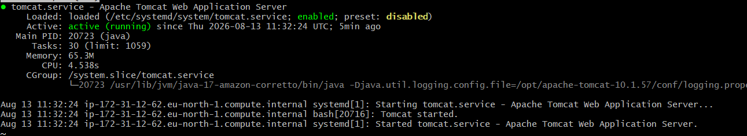
✅ Task completed.
8: Configure HA Proxy server:
HAProxy is a load balancer and reverse proxy. It receives client requests on a frontend port and forwards them to backend servers. It can distribute traffic using algorithms such as round-robin and can perform health checks on backend servers. In my setup, HAProxy listens on port 80 and forwards requests to Tomcat running on port 8082.
The request reaches HAProxy on port 80.
HAProxy then forwards it to Tomcat on port 8082.
Important configuration
frontend http_front
bind *:80
default_backend web_servers
Frontend = where HAProxy receives requests.
bind *:80 means:
Listen for incoming HTTP requests on port 80.
Then:
backend web_servers
balance roundrobin
server tomcat 127.0.0.1:8082 check
Backend = where HAProxy sends the requests.
127.0.0.1:8082 means:
Send the request to Tomcat running on port 8082 on the same EC2 server.
check means:
HAProxy checks whether the backend server is available.
- What is Round Robin?
- If there are multiple backend servers:
- Request 1 → Server 1
- Request 2 → Server 2
- Request 3 → Server 3
- Request 4 → Server 1

This is called round-robin load balancing
- Important HAProxy file:
/etc/haproxy/haproxy.cfg

- Important commands:
sudo haproxy -c -f /etc/haproxy/haproxy.cfg

- Start: sudo systemctl start haproxy
sudo systemctl status haproxy
sudo systemctl enable haproxy
- Check listening port: sudo ss -lntp | grep ':80'

